There is an undirected tree with n nodes labeled from 0 to n - 1. You are given the integer n and a 2D integer array edges of length n - 1, where edges[i] = [ai, bi] indicates that there is an edge between nodes ai and bi in the tree. The root of the tree is the node labeled 0.

Each node has an associated **value**. You are given an array values of length n, where values[i] is the **value** of the ith node.

Select any two **non-overlapping** subtrees. Your **score** is the bitwise XOR of the sum of the values within those subtrees.

Return *the* ***maximum*** *possible* ***score*** *you can achieve*. *If it is impossible to find two nonoverlapping subtrees*, return 0.

**Note** that:

* The **subtree** of a node is the tree consisting of that node and all of its descendants.
* Two subtrees are **non-overlapping** if they do not share **any common** node.

**Example 1:**

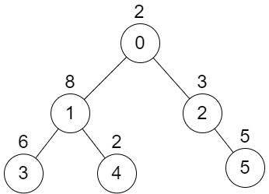

Input: n = 6, edges = [[0,1],[0,2],[1,3],[1,4],[2,5]], values = [2,8,3,6,2,5]  
Output: 24  
Explanation: Node 1's subtree has sum of values 16, while node 2's subtree has sum of values 8, so choosing these nodes will yield a score of 16 XOR 8 = 24. It can be proved that is the maximum possible score we can obtain.

**Example 2:**

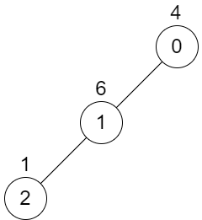

Input: n = 3, edges = [[0,1],[1,2]], values = [4,6,1]  
Output: 0  
Explanation: There is no possible way to select two non-overlapping subtrees, so we just return 0.

**Constraints:**

* 2 <= n <= 5 * 104
* edges.length == n - 1
* 0 <= ai, bi < n
* values.length == n
* 1 <= values[i] <= 109
* It is guaranteed that edges represents a valid tree.